PERSPECTIVE 1 (CUSTOMER’S PERSPECTIVE)

1. **What is the name of the website and where do I find an introduction to the website?**

Craft is the name of my business.

1. **What makes your services much different from any other companies?**

We provide handmade products with unique designs that represent the culture of the country.

1. **Are there any options for buying your products online; if so, which website do I go to?**

Yes, we create the business page on Instagram and also create the website.

1. **Accessibility/Availability of your products: are they available throughout Canada?**

We start our business from a particular area after a year we expense our business and start delivering our products through Canada.

1. **Will your products be available on other platforms such as Amazon, e-Bay, etc?**

Not this time but maybe later on.

1. **Are your product long- lasting.**

Yes, our products are hand-made made by the tradition artist.

1. **What type of theme you are using for the painting?**

Uniqueness is creativity is the theme for our products.

PERSPECTIVE 1 (INVESTOR’S PERSPECTIVE)

1. **Do you have a ‘Rating/Reviewing’ strategy available for customers on your website?**

Yes, we have. We collect feedback from our customers to overcome the drawbacks of the business.

1. **What will my investment be used for in your company?**

We use the investment in setting up our shop and organizing the workshops for the employees to enhance their skills.

1. **What are your future goals concerning the company’s growth?**

After a year we plan to open the new branch in a different location so that our market will increase.

1. **Do you have everything in place to make the business model function smoothly?**

We review our plan and strategies from time to time to achieve our goals.

1. **What’s your strategy for tackling delivery charges to the customers?**

We provide free delivery on the first order.

After receiving the feedback from the peer. I added an introduction part related to our business.

Before

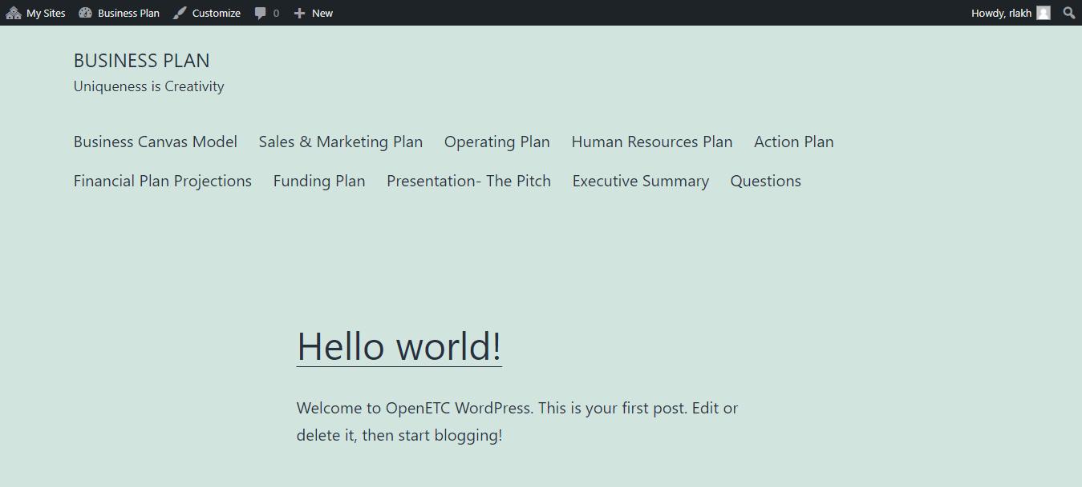

After

